**OCTOCOPTER PID MOTOR MIXING**

**PIDMIX:**

(ROLL, PITCH, YAW) PID corrections in percentage.

**CONVENTION:**

1. + Positive correction
2. -Negative correction
3. 1 Apply 100% PID correction
4. x Apply x * 100% PID correction

**OCTOCOPTER PLUS CONFIGURATION:**

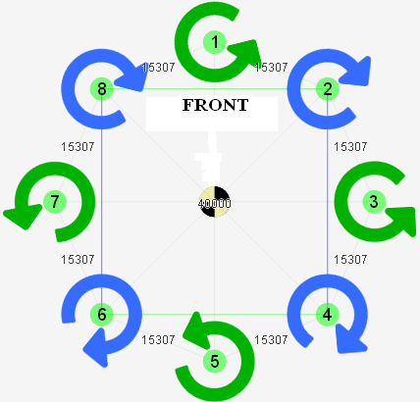

motor[1] = PIDMIX(0,-1,1);

motor[2] = PIDMIX(-0.707,-0.707,-1);

motor[3] = PIDMIX(-1,0,1);

motor[4] = PIDMIX(-0.707,0.707,-1);

motor[5] = PIDMIX(0,1,1);

motor[6] = PIDMIX(0.707,0.707,-1);

motor[7] = PIDMIX(1,0,1);

motor[8] = PIDMIX(0.707,-0.707,-1);

**OCTOCOPTER X CONFIGURATION:**

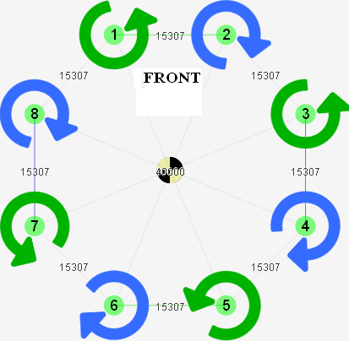

motor[1] = PIDMIX(0.414,-1,1);

motor[2] = PIDMIX(-0.414,-1,-1);

motor[3] = PIDMIX(-1,-0.414,1);

motor[4] = PIDMIX(-1,0.414,-1);

motor[5] = PIDMIX(-0.414,1,1);

motor[6] = PIDMIX(0.414,1,-1);

motor[7] = PIDMIX(1,0.414,1);

motor[8] = PIDMIX(1,-0.414,-1);